Lesson 9

Partial Fractions

sPECIFIC OBJECTIVES:

At the end of the lesson, the student is expected to be able to:
- Define partial fractions.
- Identify the different cases of partial fractions.
- Decompose fraction into partial fractions

9.1 Partial Fraction

Definition 9.1 Partial Fractions
A rational function 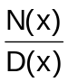 , where the degree of N(x) is less than the degree of D(x), can be expressed as a sum of two or more simpler fractions called partial fractions.

Remarks:
If the rational function is an improper fraction, that is, the degree of N(x) is greater than or equal to the degree of D(x), divide N(x) by D(x) until a proper fraction is obtained. The denominators of the partial fractions are obtained by expressing D(x) into a product of linear and/or quadratic factors. The method of determining the partial fractions depends on the nature of the factors of D(x). This leads to any of the four cases as follows:

- Distinct linear factors
- Repeated linear factors
- Distinct quadratic factors
4. Repeated quadratic factors

9.2 Fraction Decomposition

Definition 9.2.1 Distinct Linear Factor

For every distinct linear factor of the form ax + b found in D(x), there corresponds a partial fraction of the form 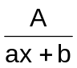 , where A is a constant to be determined.

Example 9.2.1 The following shows the resolved partial fractions belonging to the above type.

1. 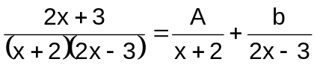

2. 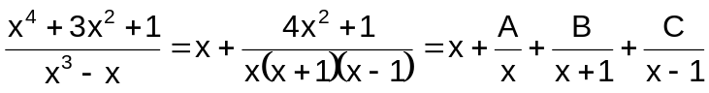

Definition 9.2.2 Repeated Linear Factors

For every linear factor ax + b, repeated n times found in D(x), there corresponds n partial fractions of the form:
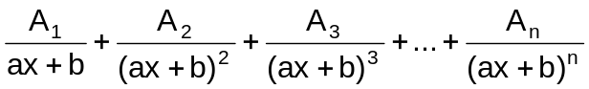
where A₁, A₂, …,A_{n} are constant to be determined.

Example 9.2.2 The following shows the resolved partial fractions belonging to the above type.

1. 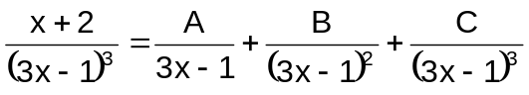

2. 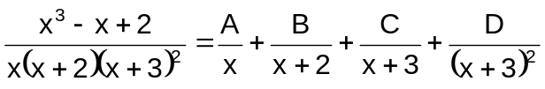

Definition 9.2.3 Distinct Quadratic Factors

For every distinct quadratic factor of the form ax² + b x + c found in D(x), there corresponds a partial fraction of the form 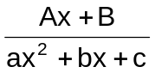 , where A and B are constants to be determined and b² – 4ac < 0.

Example 9.2.3 The following shows the resolved partial fractions belonging to the above type.

1. 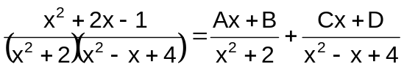

2. 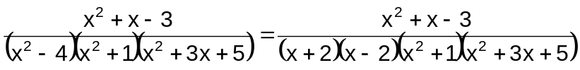

= 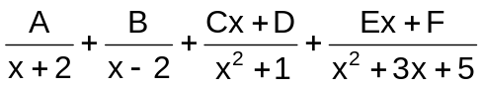
Definition 9.2.4 Repeated Quadratic Factors

For every quadratic factor (non-factorable) ax² + b x + c repeated n times found in D(x), there corresponds n partial fraction of the form
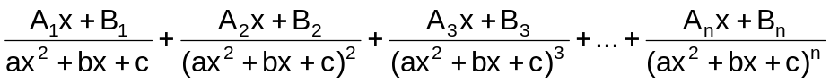
where A and B are constants to be determined and b² – 4ac < 0.

Example 9.2.4 The following shows the resolved partial fractions belonging to the above type.

1. 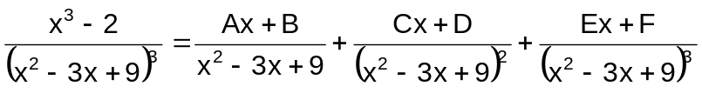

2. 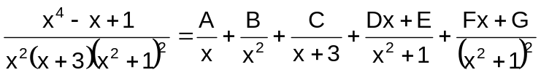

9.3 Determination of Constants in the Partial Fractions

There two ways to find the constants in the partial fractions, namely:

- By assigning values to the variable

This method uses the concept that if two polynomials are identical, then they are equal for any value assigned to the variable. The most convenient values are those that will make the denominator of the given rational function zero.

- By equating like powers of the variable

This method uses the concept that if two polynomials are identical, then the coefficient of each power of the variable in one polynomial is equal to the corresponding coefficient in the other polynomial.

Example 9.3.1 Resolve the following rational functions into partial fractions.

1.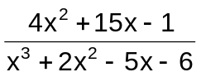 ans. 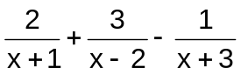

2.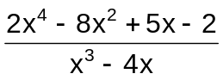 ans. 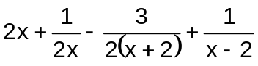
3.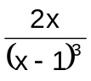 ans. 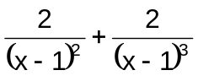

4.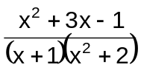 ans. 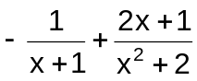

5.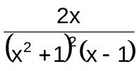 ans. 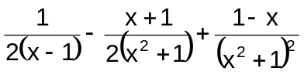

Exercise 9.3.1 Resolve the following rational functions into partial fractions.

1.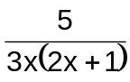 6. 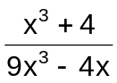

2.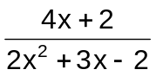 7. 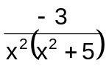

3.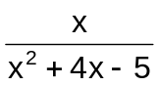 8. 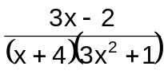

4.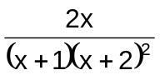 9. 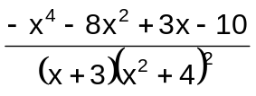

5.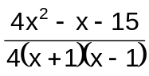 10. 